
Koneru Lakshmaiah Education Foundation
(Deemed to be University estd. u/s. 3 of the UGC Act, 1956)
Off-Campus: Bachupally-Gandimaisamma Road, Bowrampet, Hyderabad, Telangana - 500 043. Phone No: 7815926816, www.klh.edu.in

STUDENT CASE STUDY EXECUTION REPORT
Department | FED
Subject | DSA-2
Academic Year | 1-111 Semester | 2025-26
Faculty Name | Mohd. Razia Alangir Banu
Student Name | P. Yaswanth Surya
Roll Number | 2520030581
Branch | CSE
Course Outcome | CO 5
Case Study Topic: Patient Record Management using Sorting Algorithms
Work Done Summary:
In this case study, we implemented Sorting Algorithms to organize hospital patient records efficiently. The system sorts patient records based on Patient IDs to enable faster searching, retrieval, and management of patient information. Sorting helps hospital staff access records quickly and improves overall data organization.

Implementation Details:

• Stored patient records with Patient IDs.
• Implemented a sorting algorithm (Quick Sort/Merge Sort).
• Sorted patient records in ascending order.
• Displayed records before and after sorting.
• Compared unsorted and sorted datasets.
• Improved record retrieval efficiency.
• Analyzed sorting algorithm performance.

. 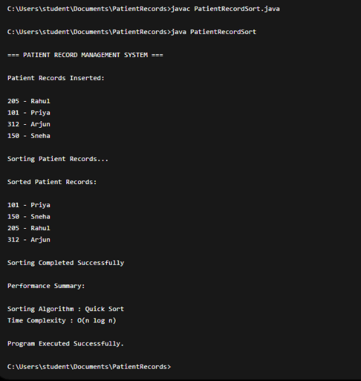

Result: Screenshots / Output

Time Complexity:
• Best Case: O(n log n)
• Average Case: O(n log n)
• Worst Case: O(n²) (Quick Sort)
• Space Complexity: O(log n)

Conclusion:
Sorting Algorithms efficiently organized patient records based on Patient IDs. The sorted records improved data accessibility and reduced search time. Quick Sort provided fast and effective performance for handling large hospital databases.

GitHub Link: https://github.com/yaswanthsurya-99/DSA-2
Student Signature Faculty Signature

